Now we're going to take a look at deleting complete database tables themselves.

First thing is, you will only be allowed to delete your own customer-specific tables. You will not be allowed to delete SAP delivered tables.

Now because we have just created this ZEMPLOYEES3 table, we will use this in our example for deleting the table. But before that I just want to show you a technique for checking that everything is okay for you to delete the table, and you will not affect other parts of the system.

So, what I'm going to do is go back to our ZEMPLOYEES table. Because we have included this table in the ABAP programs we have created so far.

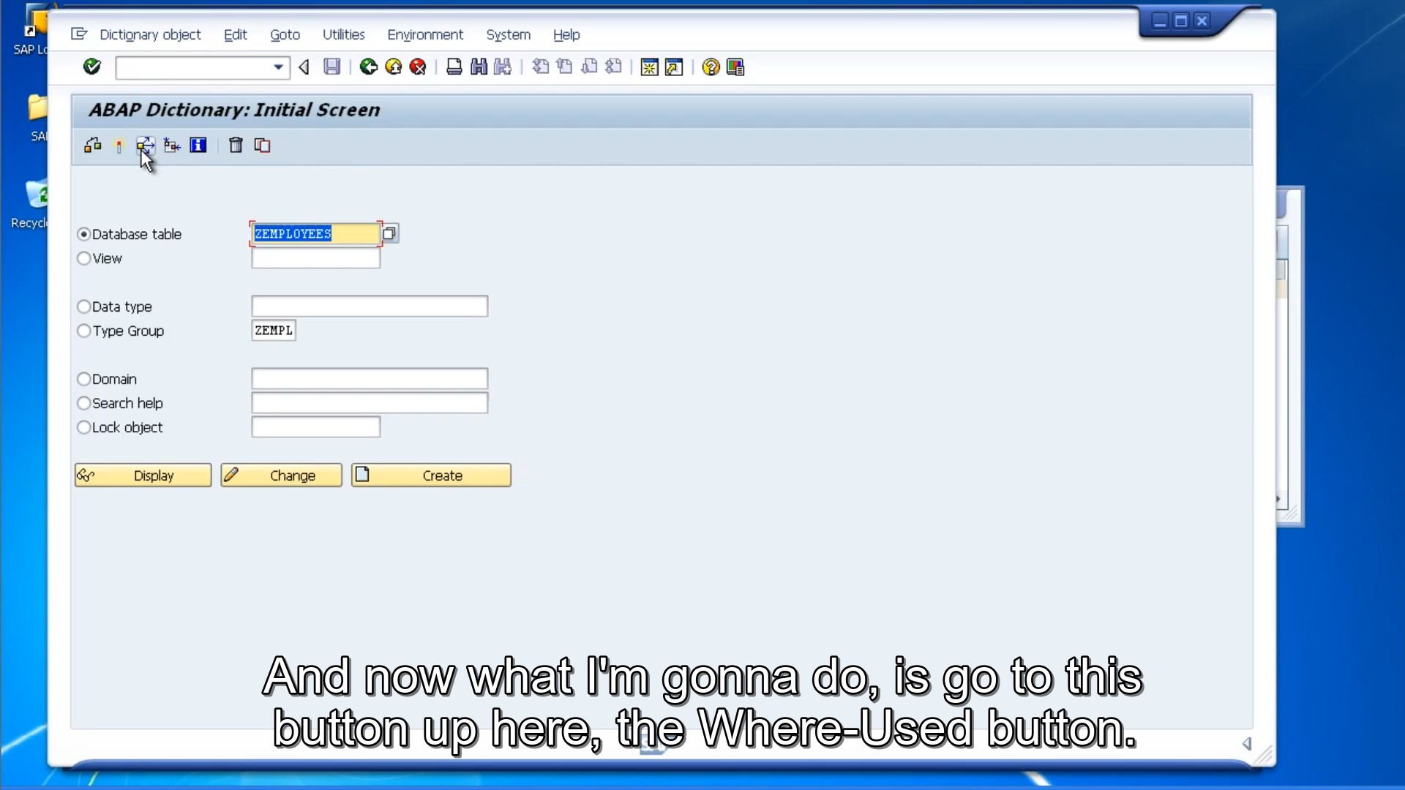

And now what I'm going to do, is go to this button up here, the Where-Used button. So, if we click the button, the system then brings up a dialog box where we go through and choose the objects we want to look through.

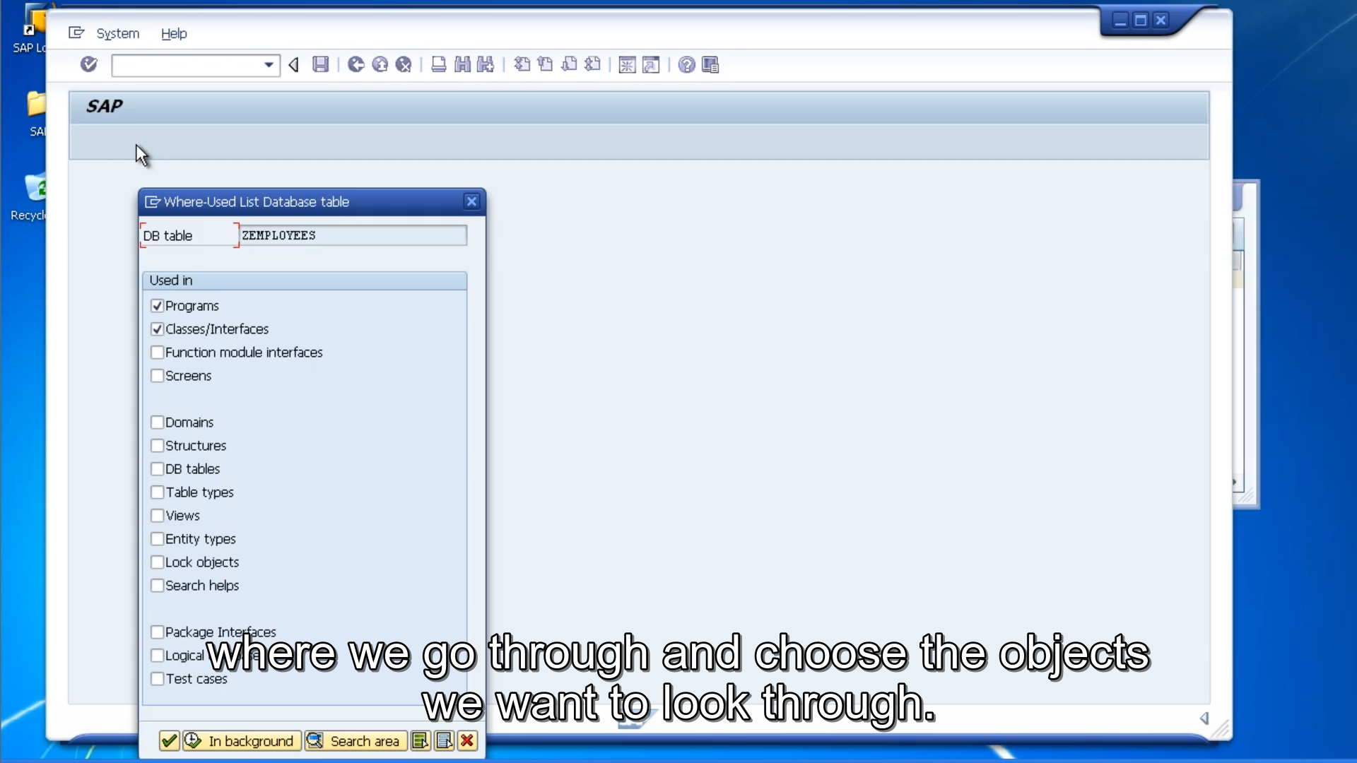

So, what this is going to do is check all the different types of objects that we have in our system that we select. For a reference to our table is ZEMPLOYEES.

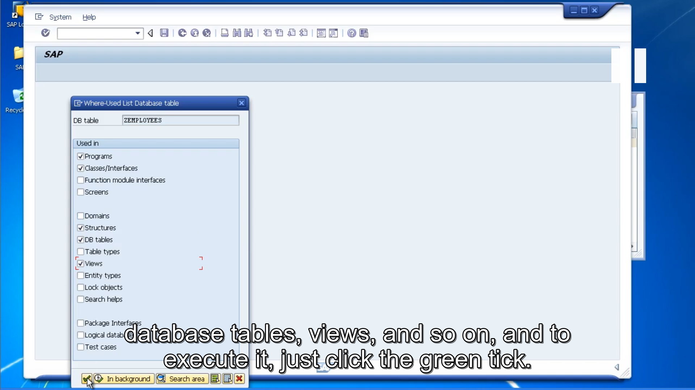

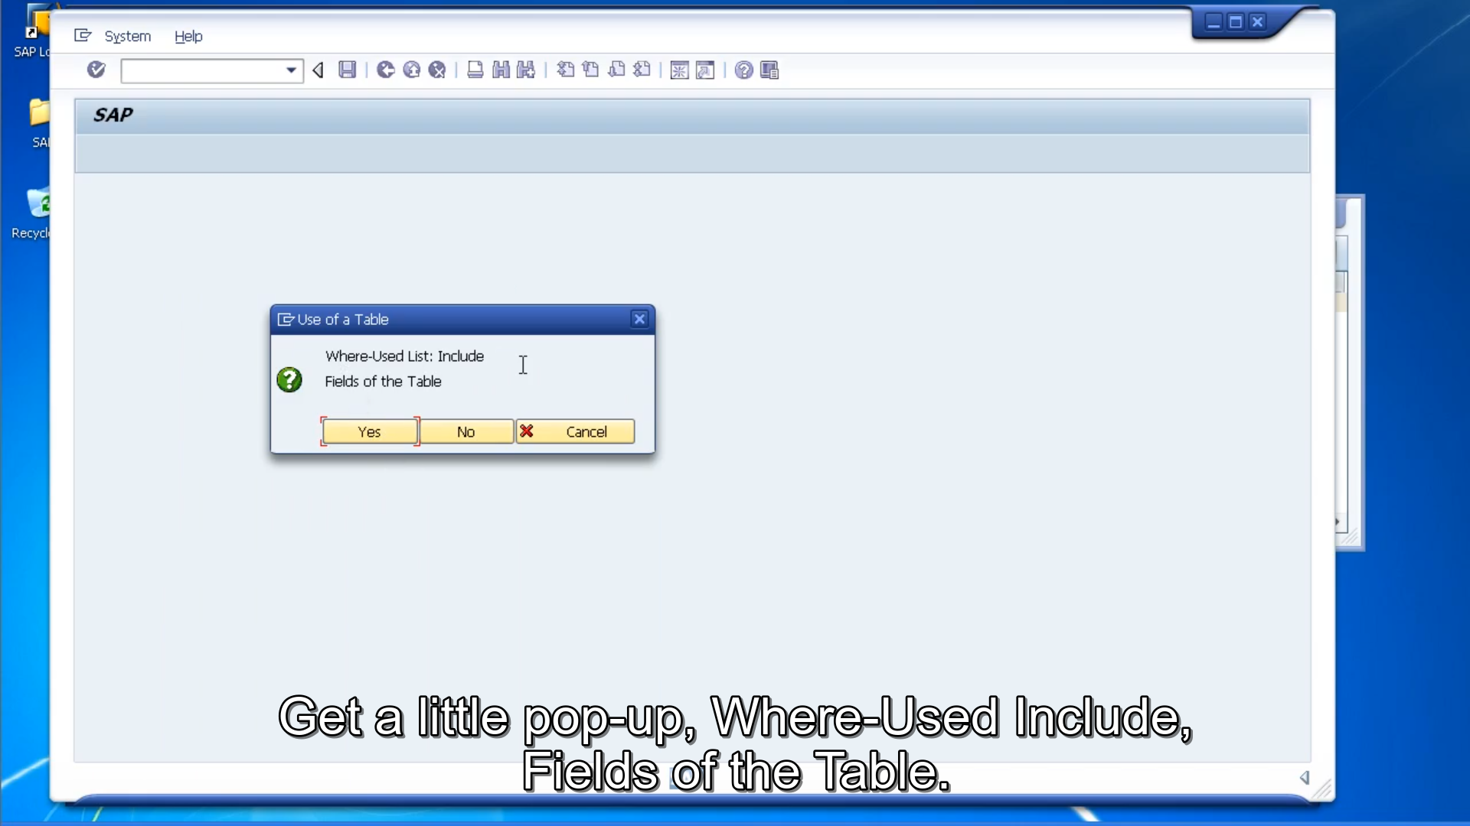

Get a little pop-up, Where-Used Include, Fields of the Table. We just choose Yes. So, the system's going away and checking all of the different objects that we have selected to find references to our table. And there it's come back and it's shown us, we have two programs that are using this table.

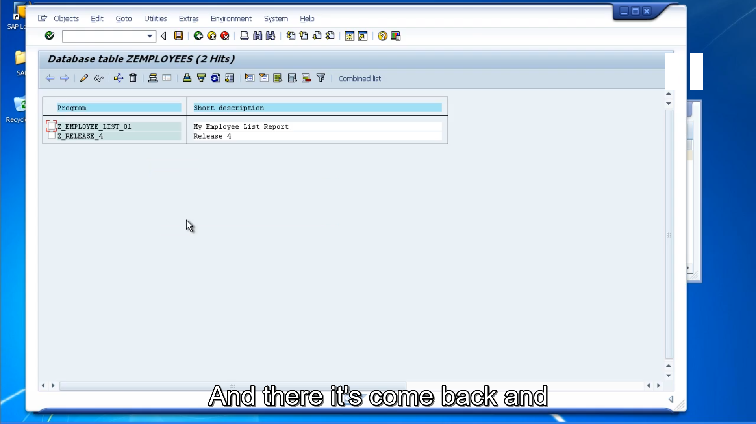

So immediately we know that if we delete this table these programs are going to become inactive. They're not going to work anymore.

Now, if we try to delete this table now the system will not let us do it because we have objects that dependent on it.

So, what you would have to do is find those programs, take some course of action to either edit the code, take out references to the table or remove the programs completely before you could then come back and delete this table. So, what we will do is change the table name. And we'll use the ZEMPLOYEES3 table that we created in the previous videos. And we will choose to delete this table. As you can see, we're presented with a message box telling us the table contains data, and we know this, but we just want to delete the table anyway.

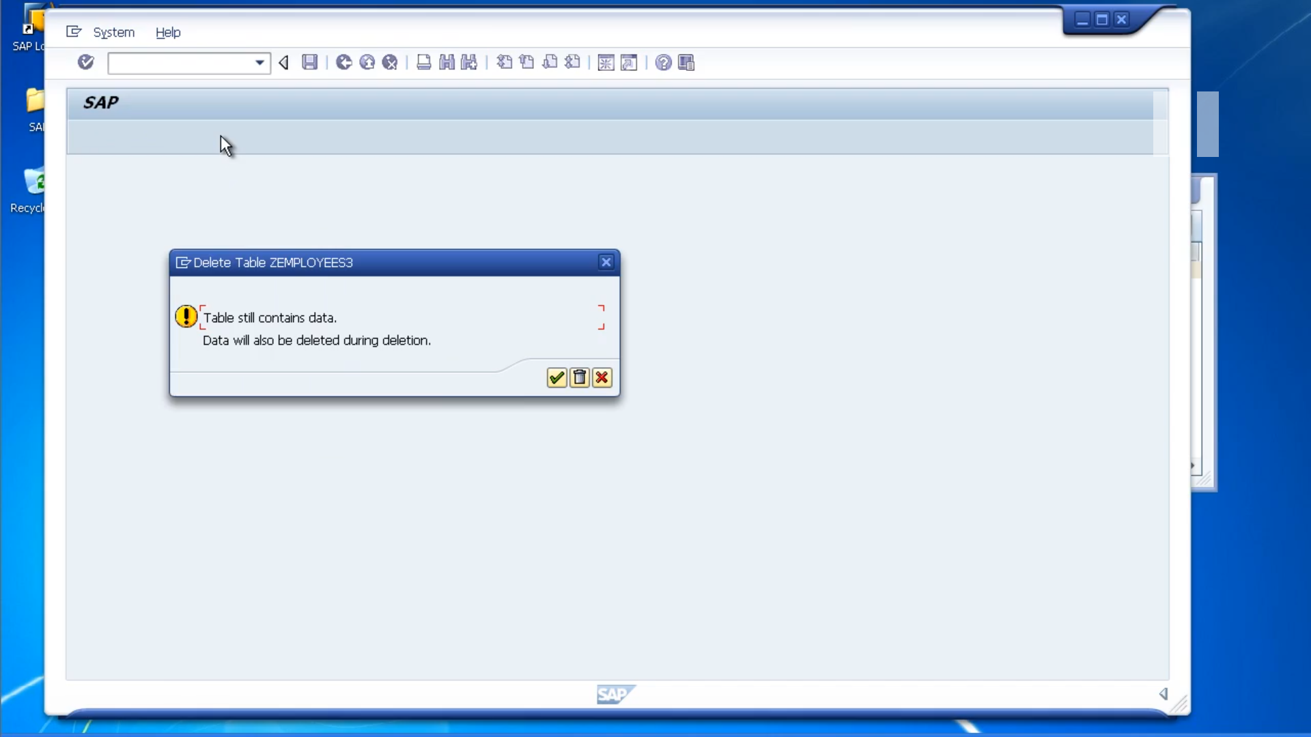

If you click the green tick button, we will be taken back to the previous screen, and the table would not be deleted, but if you click the little trash can, the table will get deleted. And there we have the confirmation message at the bottom, saying the table was removed. If we try and display it, we can see it does not exist.

Now one final note, is that now we've deleted the table, we cannot undo this process. The table is gone completely. So, before you click that trash can button, make sure you do want to delete the table.